Jackson County Fire District #1
Invites applications for the position of:

Fire Chief
$110,000 - $130,000
Plus Benefits

Opening Date: July 1, 2026
Closing Date: July 31, 2026

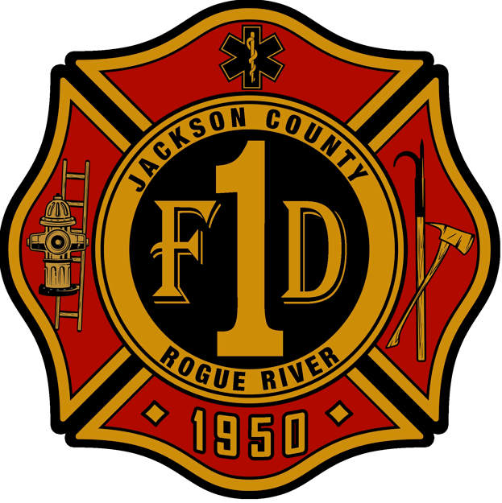

POSITION ANNOUNCEMENT
Fire Chief
The Jackson County Fire District #1 is currently recruiting qualified applicants to fill the Fire Chief position.
The Jackson County Fire District#1 (JCFD #1) serves Rogue River, Oregon and the surrounding area from one station located in Rogue River. The Fire District is governed by a five-member Board of Directors elected by the district's voters. The JCFD #1 provides fire response, Advanced Life Support (ALS) ambulance response and transport to local hospitals. JCFD #1 also provides rescue boat response on the Rogue River.
Responsibility for management and administration of District activities resides with the Fire Chief who is appointed by the Board of Directors. The JCFD #1 presently employs 16 full-time, 3 seasonal employees and up to 6 students.

Qualifications for the successful a1i1ilicant include:
- Proven leadership in a similar or larger organization.

- At least 10 years of fire service experience and at least 5 years of command experience with administrative, management and supervisory duties.
- Associates degree in fire administration, EFO, CFO or equivalent educational achievements.

- Valid Oregon driver’s license or ability to obtain and be insurable by district insurance provider.

- Provin ability to work within NIMS, and ICS at command level. Ability to effectively assume command in both initial and extended attack when needed.
- Work cooperatively with local, state and federal partners in unified command.
Any satisfactory combination of experience, training, skills and ability that demonstrates the above may be considered.

Desirable Qualifications include:
- Bachelors' degree in Fire Administration, Public Administration or related field.
- Paramedic or past experience working as a Paramedic.
- Live within district boundaries within 6 months of employment.

POSITION OBJECTIVES
The JCFD #1 is looking to hire a person who will provide the leadership, management skills and administrative abilities to continue to move the district in the direction of its stated mission.

Mission:

Jackson County Fire District 1 is a combination career and volunteer organization providing fire protection, emergency medical and other related services that meet the current and future needs of the community.

THE IDEAL CANDIDATE
The individual appointed to this position will possess well-developed fire/EMS operations, business management, administrative and leadership skills. They will recognize that policy is set by the Board of Directors and will provide an open and direct flow of information to assist in the formulation of District policies.

They will also:
- Be an excellent communicator and representative of the district.
- Act as a catalyst and "front" person who can help the Board of Directors, Staff, and the communities create a vision to build for the future.
- Promote ideas and concepts and sell them in the broader community.
- Maintain responsibility for establishing and nurturing successful press relations.
- Help the fire district grow and adapt to changing conditions and continue to be actively involved in the region and state.
- In relationships with staff, this person will be a good listener and mentor; and be accessible and
open in dealings with people who work for the district.

Salary Range: $ 110,000 - $130,000 - Excellent benefit package
Desirable Starting Date: January 1, 2027

To be considered please submit a letter of introduction, resume, and completed application by email or postal service to:

Attn. Shanta Carter, SDAO
C/O Jackson County Fire District 1 Selection Process
PO Box 23879
Tigard, Oregon 97281

Email: scarter@sdao.com

Application Deadline:

Job description available at www.sdao.com

